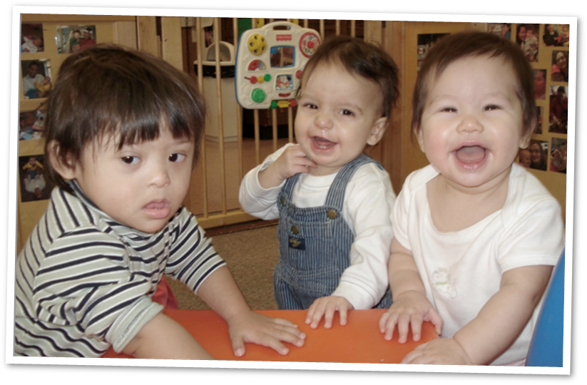
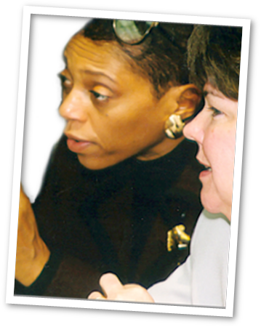

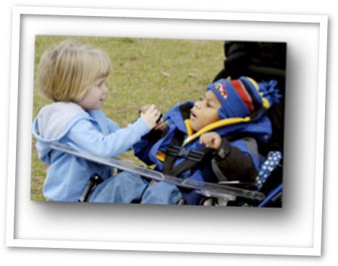
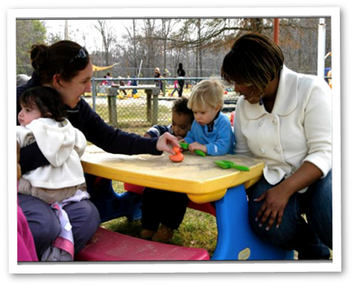
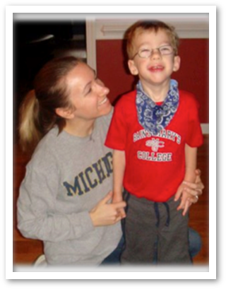







Foundations of Inclusion Training Curriculum:
Facilitator’s Guide
(Revised October 2013)

Objectives
At the completion of this workshop, participants will be able to:
- Define inclusion and features of early childhood inclusion,
- Discuss the legal and policy foundations of inclusion,
- List research-based inclusion practices, and
- Identify actions that early care and education professionals might take to build a high quality inclusive program.

Resource Checklist
You will need the following:
- Foundations of Inclusion - Birth to Five video*
- Foundations of Inclusion Training Workshop PowerPoint slides
- Handouts:
    - Foundations of Inclusion Video Discussion Questions
    - Foundations of Inclusion Policy Advisory: Rights for Children, Parents and Teachers Related to Inclusion
    - Admission Policies and Practices that Build Inclusive Child Care Communities
    - Research Synthesis Points on High Quality Inclusive Practices
    - Finding Inclusion Partners: Websites that Help
    - Foundations of Inclusion Action Planning Form
    - Foundations of Inclusion Glossary
- Sign In sheets
- Sign Out sheets
- Pre Survey
- Post Survey
- Evaluation Sheets
- Chart paper and markers
- Find a partner(s) to co-facilitate or be guest speakers: e.g., parent of a child with disabilities or therapists, teachers and directors who work in high quality inclusive settings. This can help provide participants hear real life stories of how high quality inclusion can take place and learn about the benefits of inclusion.
- BE PREPARED! If you don’t have an internet connection at your PD venue, download the video beforehand.

Agenda
- Introduction - 10 minutes
- Foundations: View Foundations of Inclusion Birth to Five video - 20 minutes
- Build Your Knowledge: Learn more about how you can include children with disabilities by reviewing handouts related to rights and responsibilities, research, finding community partners and developing inclusion policies - 35 minutes
- “I Have This Child...” Activity: Create an action plan to include a child with disabilities in your classroom or program - 45 minutes
- Conclusion - 10 minutes
Total time: 120 minutes (2 hours)

I. Introduction - 10 minutes
Delivery Style: Presentation
Required Resources: Sign in sheets, pre-survey
Activity Sequence
- Slides 1 – 3: Introduce yourself and the agenda. Select a strategy of your choosing to have participants introduce themselves.
- Slide 4: Review with participants the objectives:
  - At the completion of this module, participants will be able to:
      - Define inclusion and features of early childhood inclusion,
      - Discuss the legal and policy foundations of inclusion,
      - List research-based inclusion practices, and
      - Identify actions that early care and education professionals might take to build a high quality inclusive program.
- Slide 5: Invite participants to identify other questions that they may have. Acknowledge which questions will be answered in this session and note questions that need to be referred to other sources.
- Slide 6: Conduct pre-survey.

II. Foundations - 20 minutes
Pre-Workshop Facilitator Preparation: Review the Foundations of Inclusion Birth to Five video as well as the Foundations of Inclusion Video Discussion Questions (Note: You will need to hyperlink the video to the image in Slide 9 if you want to play the video directly from the PowerPoint slide).
Delivery Style: Video and Large Group Discussion
Required Resources
    - Foundations of Inclusion Birth to Five video
    - Foundations of Inclusion Video Discussion Questions
    - Chart paper and markers
Activity Sequence
- Slides 7-8: Prior to watching the video, ask participants to form small groups or pair up with the person sitting next to them. To help the participants think more deeply, ask participants to review the Foundations of Inclusion Video Discussion Questions and assign one discussion question per group or pair to focus on.
- Slide 9: Play the Foundations of Inclusion Birth to Five video or ask participants to read the transcript. Note that the video could be paused at different points for discussion purposes or viewed as a whole before inviting responses. (You may ask the group for their preference or simply choose as the instructor)
- Slide 10: Provide participants time to discuss their responses to their target question with their group or partner.
- Lead a facilitated large group discussion about participants’ responses to the Foundations of Inclusion Video Discussion Questions.

Ideas for Activity Extension
- Role play – Ask participants to role play a parent with a child with disabilities talking with a school director who says the child cannot attend the child care program.
- Prior to showing the video, ask participants to reflect on what outcomes they would like for children with disabilities.

III. Build Your Knowledge - 35 minutes
Pre-Workshop Facilitator Preparation: Review all 4 handouts and select one discussion activity option per handout or adapt and develop your own activity. Make your decision or adaptations based on the roles or experience your participants may have or what you think will best meet their needs. (Note: For some activities, you may have to make copies of additional handouts for participants or review additional materials ahead of time)
Delivery Style: Reflection and Discussion - 5 minutes instructor review of activities; 10 minutes for pair or small group discussion; and 15 minutes for discussion and five minutes for instructor to help summarize. Times approximate. Adjust for group.
Required Resources
    - Foundations of Inclusion Birth to Five video
    - Foundations for Inclusion Policy Advisory: Rights for Children, Parents and Teachers Related to Inclusion
    - Admission Policies and Practices that Build Inclusive Child Care Communities
    - Research Synthesis Points on High Quality Inclusive Practices
    - Finding Inclusion Partners: Websites that Help
Activity Sequence
- Slides 11-12: Review the last segment of the video together (Time frame: 10:45 – 12:02).
- Remind the participants why it is important to be familiar with the laws, policies, and research on inclusion:
  - 1) They are legally obligated to serve children with disabilities in their programs. Understanding teachers’, families’ and children’s rights is therefore critical to their work, and
  - 2) Knowing and learning how to implement the best practices found in research will help them ensure greater success in supporting children with disabilities and their families.
- Slide 13: Provide participants time to review all 4 handouts.
- Slides 14-17: Review with participants the discussion activities you have selected for them to work on.
- Discussion Activities
- Referring to Foundations of Inclusion Policy Advisory: Rights for Children, Parents and Teachers Related to Inclusion,
Option A: Choose a right and a responsibility for teachers and a right and a responsibility for families related to inclusion that you might not have been aware of prior to reading this document, or that you think your colleagues are unaware of. Discuss next steps you can take based on your new knowledge of these rights (e.g., talking to your director about attending an IEP meeting or going for additional professional development, etc.).
Option B: Develop a plan on how you and your program can help families of children with disabilities understand their rights.
- Using the Admission Policies and Practices that Build Inclusive Child Care Communities,
Option A (For directors) (Facilitator’s note: Prior to the workshop, make copies of the sample policy, Enrollment and Admission Policy, and the guide on developing inclusive policy, Writing an Inclusion Policy for the participants. Both resources are available at: http://ccids.umaine.edu/resources/ec-growingideas/admissionsll/): Review the sample policy and guide on developing inclusive policy. Work in small groups and use the guide to develop a set of policy guidelines that reflect a welcoming environment for all children and families.
Option B (For directors) (Facilitator’s note: Prior to the workshop, contact participants to ask them to bring copies of their program policies. Also, make copies of the sample policy, Enrollment and Admission Policy, and the guide on developing inclusive policy, Writing an Inclusion Policy for the participants. Both resources are available at: http://ccids.umaine.edu/resources/ec-growingideas/admissionsll/): Review your individual program’s existing policies and make notes on your policies as to what or how you can make changes to make them more inclusive. Then share back with the large group some of the changes you plan to make.
Ideas for extension of Options A and B: Discuss how to put procedures in place to communicate your program policies to staff and families as well as to have a regular (e.g., bi-annual) review of the policies with staff and families.
Option C (For teachers): Identify three ways to create a welcoming environment for all children and families.

- Referring to Research Synthesis Points on High Quality Inclusive Practices,
Identify two research-based practices that you would like to start using in your classroom to support the learning and development of all children in the classroom. Discuss how these can be aligned to standards or requirements, (e.g., Common Core, Early Learning Standards, etc.) and how you can use these interventions and strategies to support the learning and development of all children in the classroom.
Ideas for Activity Extension: (Facilitator’s note: Prior to the workshop, review the pictorial and video examples below of research-based practices, download the videos and print copies of the handouts that you plan to use with the learners). Watch the videos or review photo examples and discuss in a small group or pairs which practices you would like to try out in your classroom and the supports you might need in order to successfully implement these practices.
  - Picture examples:
Environmental modifications: http://community.fpg.unc.edu/sites/community.fpg.unc.edu/files/resources/Handout/CONNECT-Handout-1-1.pdf

Peer support:
http://community.fpg.unc.edu/sites/community.fpg.unc.edu/files/resources/Handout/CONNECT-Handout-1-2.pdf
Assistive technology:
http://community.fpg.unc.edu/sites/community.fpg.unc.edu/files/resources/Handout/CONNECT-Handout-5-2.pdf
http://community.fpg.unc.edu/sites/community.fpg.unc.edu/files/resources/Handout/CONNECT-Handout-5-3.pdf
  - Video examples:
Embedded interventions:
http://community.fpg.unc.edu/connect-modules/resources/results/taxonomy%3A3%2C34%2C14
Assistive technology:
http://community.fpg.unc.edu/connect-modules/resources/results/taxonomy%3A3%2C38%2C6%2C52
- Referring to Finding Inclusion Partners: Websites that Help,
Option A: Identify individuals (e.g., early interventionists, early childhood special education consultants, family advocates) in your community who are currently partners with you or could be contacted for the purpose of developing partnerships that support high quality inclusion.
Option B: (Facilitator’s note: Referring to the example of a matching game which has North Carolina specific resources, adapt or create a similar game with community resources in your state. The instructions for both facilitators and learners are also provided in the link below: http://community.fpg.unc.edu/sites/community.fpg.unc.edu/files/resources/Activity/Matching%20Game%20Activity%20for%20Build%20Your%20Knowledge.pdf).
Slides 18-19: Then,
- Ask participants to form pairs or small groups (depending on group size) and select one of the four activities to develop a response.
- Ask each pair or group to take notes so that they can share their responses with the larger group.
- At the conclusion of the discussion ask participants to discuss how the information from each of these activities helps to build their knowledge about how to support all children and families in their setting.

IV. “I Have This Child...” Activity - 45 minutes
Pre-Workshop Facilitator Preparation: Review the Foundations of Inclusion Action Planning Form and suggested options for conducting the activity below. Choose one option for participants to work on or make adaptations based on your knowledge of the participants’ needs.
Delivery Style: Small Group Discussion - 10 minutes for preliminary pairs or small group discussion; 15 minutes for small group brainstorming and documentation of their thinking; and 20 minutes for feedback and discussion. Times approximate. Adjust for group.
Required Resource: Foundations of Inclusion Action Planning Form
Activity Sequence
Slides 20-21
- Option A: Ask participants to think about a child who would be challenging to serve in their program or classroom now because of her or his developmental or educational needs. This child could be based on past or current experiences but ask them NOT to talk about a real child in a way that could identify that child in order to protect confidentiality.
- Option B: Ask participants to imagine that one of the following children is enrolled in their classroom: A child ….
- ….who learns easily but has a visual impairment that affects his mobility and access to materials and activities in the classroom.
- …..who enjoys focusing intensely on certain tasks but is withdrawn from other children and group activities in spite of efforts to support his or her involvement.
- ……who has high positive energy but cannot stay focused or engaged for over one minute in any activity or task.
- …..who started the year well but has recently become overly aggressive with other children to the point that they are avoiding him or her.
- ….who has a sweet personality but multiple developmental delays that affect speech and motor skills.
- Option C: Ask participants to watch the video on Jackie’s dilemma regarding including a child with disabilities in her classroom: http://community.fpg.unc.edu/connect-modules/resources/videos/video-1-1.
- Slide 22: Ask participants to work in pairs or small groups and discuss their perceptions of the challenges associated with having the child in their program.
- Encourage participants to think deeply about why the child or family presented a dilemma including knowledge gained from previous activities.
- Ask participants to choose one of the children or families from the joint discussion and develop a group or pair response using the guiding questions in the Foundations of Inclusion Action Planning Form.
- Debrief each pair or small group discussions with the large group. As you debrief with the group,
- Encourage thinking about how early discussions and planning with families can support a successful experience for all children.
- Support participants in integrating ideas and information from the session into their discussions.
Alternate Activity
Recipe for Success Activity – The instructions for this activity can be found here: http://community.fpg.unc.edu/sites/community.fpg.unc.edu/files/resources/Activity/Recipe%20for%20Success%20Activity%20for%20I%20have%20this%20child.pdf

V. Conclusion - 10 minutes

Required Resources
    - Sign out sheets
    - Post survey
    - Evaluation sheets

Activity Sequence
- Slides 23-24: Review workshop objectives:
  - Define inclusion and features of early childhood inclusion,
  - Discuss the legal and policy foundations of inclusion,
  - List research-based inclusion practices, and
  - Identify actions that early care and education professionals might take to build a high quality inclusive program.
- Slides 25-27: Remind participants that there are several ways to go deeper and learn more about inclusion – e.g., CONNECT online courses, follow-up coaching or mentoring (if any, with you), etc.
- Slides 28-29: Ask participants to complete post survey and evaluations.
- Slides 30-31: Provide participants with a chance to ask questions. Thank participants for participation.

Citation

CONNECT. (2013). Foundations of Inclusion Training Curriculum: Facilitator’s Guide. Chapel Hill: University of North Carolina at Chapel Hill, Frank Porter Graham Child Development Institute, Author.

Acknowledgments
Center for Community Inclusion and Disability Studies at the University of Maine for permission to use Admissions Policies and Practices that Build Inclusive Child Care Communities (for Providers), 2011.
Early childhood professional development coordinators and other North Carolina Child Care Resource and Referral professionals who attended the train-the-trainers workshop on the Foundations of Inclusion training curriculum for helping to pilot and provide feedback for this training curriculum.
Lanier DeGrella at North Carolina Child Care Services Association for permission to use Finding Inclusion Partners: Websites that Help.
National Professional Development Center on Inclusion (NPDCI) at Frank Porter Graham Child Development Institute, UNC-CH for permission to use Research Synthesis Points on Early Childhood Inclusion, 2009, and Research Synthesis Points on High Quality Inclusive Practices, 2011.
North Carolina Child Care Resource and Referral Council for instigating this work and for organizing the train-the-trainers workshop.

Revised October 2013

